KHC – Soapbox Challenge 2024

Design and Safety Rules

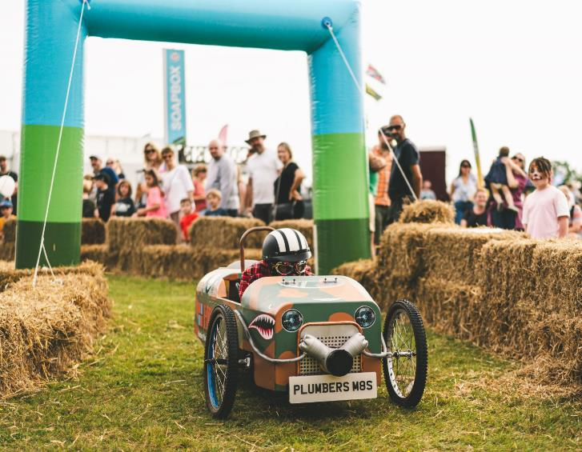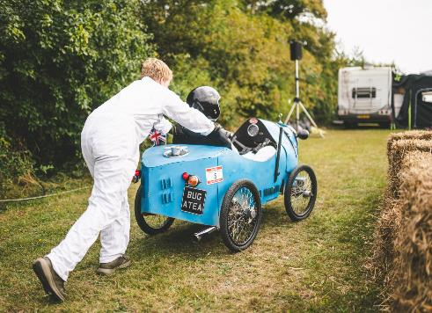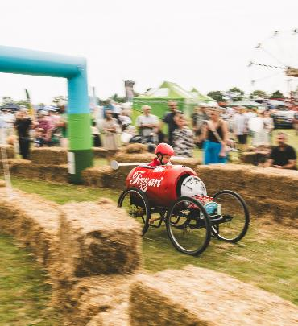

Introduction
The intention is to provide an extra-curricular activity for children aged 8 to 16 to participate in the design, construction, maintenance and competition of a soapbox cart.

Competition
The 2-day event will be run as follows (all times are approximate):
Saturday
08.00: Unload Soapbox carts to pre-designated pit area
08.30: Sign in and meet the teams
09.00: Scrutineering of carts as per Soapbox Construction Rules
10.00: Practice runs for each driver
12.00: Event closed for lunch. Family entertainment may be available in the Family Area during the Lunch period.
13.30: Round 1 – Soapbox race runs.
15.30: Event closed. Family entertainment may be available in the Family Area until 5pm

Sunday
10.00: Round 2 – Soapbox race runs.
12.00: Event closed for lunch. Family entertainment may be available in the Family Area during the Lunch period.
13.30: Round 3 – Final Soapbox race runs.
16.00: Presentation of medals, trophies and prizes.
The start ramp will be used to provide the only “thrust” for the competing carts.
The course has been designed as a short-mown grass track with a chicane and a curved bend.
Run Numbers will be provided and must be prominently displayed on each soapbox.
The team name and any sponsors or supporters logos must also be prominently displayed.
The organisers reserve the right to disqualify any participants that demonstrate inappropriate conduct.
The distance that a cart achieves will be recorded for each run.

Table of Contents
Introduction 2
1. Competition 2
2. DISCLAIMER 3
3. APPLICATION AND INTERPRETATION 4
4. PROPULSION 4
5. BRAKES 4
6. STEERING 4
7. DRIVING POSITION 4
8. DIMENSIONS AND WEIGHT 5
9. BODYWORK AND SAFETY FEATURES 6
General 6
Access 6
Driver Protection 6
Batteries 6
10. BALLAST 6
11. CLOTHING 7

DISCLAIMER
No expressed or implied warranty of safety shall result from publication of, or compliance with, this specification. This specification is not a guarantee against injury to a participant, spectator or official.
The event organisers shall be allowed to impose any further restrictions and to permit deviations from any of these specifications that in their opinion do not lower these requirements. Any deviations from this specification are left to the discretion of the event organisers. No expressed or implied warranty of safety shall result from any such deviation from this specification.

APPLICATION AND INTERPRETATION
In all matters regarding the interpretation and application of the rules detailed in this document, the organisers’ decision is final.

PROPULSION
The vehicle must be powered by gravity alone. No propulsion system or unit of any kind may be used.

BRAKES
- The vehicle must have braking on at least 2 wheels on the same axle.
- The brakes must be capable of holding the vehicle (with the driver on board) stationary on the start ramp at the start of each race run.

STEERING
- The steering must not; be overly sensitive or have excessive free play and must be suitably engineered for the speed and design of the course.
For the avoidance of doubt:
- "Rope and plank" steering is not allowed.
- "Feet on the front axle" steering is not allowed.

DRIVING POSITION
- The driver will ride alone, feet first.
- Only seated, or reclined driving positions are allowed. Prone or headfirst driving positions are not allowed.

DIMENSIONS AND WEIGHT
- Maximum overall length - 2000mm.
- Maximum overall width - 1000mm.
- Maximum weight of vehicle – 100Kg*.
- Minimum of three wheels.
- Minimum wheel diameter of each wheel 250mm.
- Ground Clearance – Minimum 150mm Maximum 250mm.
*A tolerance of 5% shall be allowed on the measurement of the maximum weight. Any deviation over this margin will be classed as a failure to meet the technical requirements.
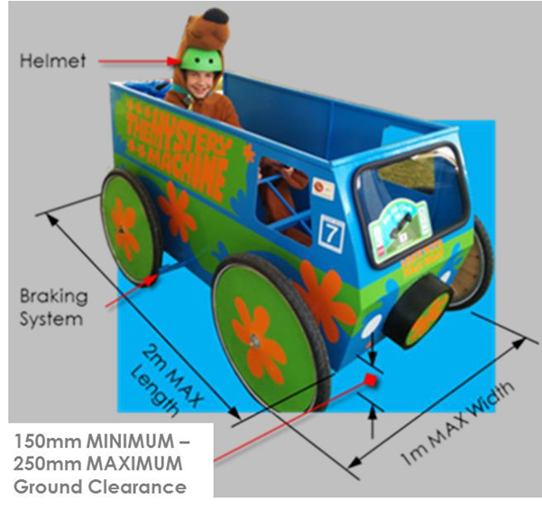

BODYWORK AND SAFETY FEATURES

General
- The vehicle must have a solid floor, and the driver must be enclosed within the vehicle from the waist down to provide suitable protection in order to avoid injury.
- There must be no sharp edges or protrusions either inside or outside the vehicle.
- Materials that might shatter on impact are not permitted.
- Any steering column, brake lever or other protrusion must be designed and fitted such that puncture injuries cannot happen.
- No part of the vehicle may be jettisoned during the run.
- At rest (at the start and the finish) the vehicle must remain upright and in racing configuration, without any part of the rider’s body being in contact with the ground.
- No changes to the kart after scrutineering, apart from repairs.
- Teams are responsible for the ongoing risk assessments of their kart throughout the event and are obliged to report any risk to the scrutineers.

Access
- Bodywork and controls must not impede the driver in exiting the vehicle unaided.
- Any doors or hatches required for driver access must be readily operated from both inside and outside the vehicle without the use of tools. The driver must be able to exit the vehicle unaided within thirty seconds. Handles, latches, etc. for access points not easily visible must be clearly marked.

Driver Protection
The following are recommended but not a requirement:
- A substantial roll-over bar above or to the rear of the driver’s head. It shall be in a suitable position to protect the head, neck and spine of the driver should the vehicle become inverted or topple on to its side.
- A 4 or 5 point safety harness may be fitted. Shoulder strap anchor points should be placed in accordance with the harness manufacturer’s instructions.

Batteries
- Any batteries should be non-leaking and properly secured.

BALLAST
- Additional ballast is not permitted, e.g. tool boxes, sand bags, paving slabs etc.

CLOTHING
- The driver’s body and limbs must be fully covered by abrasion resistant clothing for speeds up to 20mph. This can include; sturdy jacket, jeans, overalls, a karting suit, motorcycle leathers or similar. Sturdy closed toe footwear and abrasion resistant gloves must be worn. Fancy dress costumes are perfectly acceptable and encouraged providing they offer abrasion resistance for up to 20mph.
- The driver must wear a motorcycle or cycle helmet at all times when competing. The helmet must at least comply with, and carry the appropriate markings for, any one of;

  - BSI 6658-85

  - BSI 2495-77

  - EN 22.05

  - DOT FMVSS 218

  - SNELL M2005, M2010, SA/K2005 or K-98

  - ACU Approved

The helmet may be “open-face” or “full- face”.
Drivers will not be permitted to race if they do not wear the appropriate clothing.
